DBMS PROJECT:

BANK DATABASE MANAGEMENT SYSTEM

GROUP 6

Group Members:-
- Vaibhav Ranshoor (171080067).
- Akshay Vaje (171080069)
- Prathamesh Bendal (171080076).

Project Abstract:-
With the rapid globalization of the Indian economy, enterprises are facing with ever changing competitive environment. Enterprises are adopting strategies aimed at developing competitive advantage based on enhanced customer value in terms of product differentiation, quality, speed,service and costs. Today, the financial service sector witnessing a complete metamorphosis and technology is playing a very significant role in this record. This capability has provided a tremendous impetuous to thedomestic banking industry in India to deploy the latest in technology, particularly in the Internet banking and e-commerce arenas.
Banks are growing in size by mergers and acquisitions, whichhave been driven by communication and technology.
Over the last decade India has been one of the fastest adopters of information technology, particularly because of its capability to provide software solution toorganizations around the world. Technology is playing a major role inincreasing the efficiency, courtesy and speed of customer service. It is said to be the age of E-banking.

An Online Banking user is expected to perform at least one of the following functions online:
1. Checking account balance.
2. See Transaction Details.
3. Transfering funds between accounts.

In this project we will try to execute all the above functions.

Problem Statement:-
Our Aim is to provide transparency in the field of banking and make the process of deposit/withdraw from a bank hassle free and transparent and make the system of banking more effective and easy.

A Banking system can collect money in form of deposit from many Customers, they maintain an account of each Customer and record their personal details and bank balance. Banks can also give money to Customers in form of withdrawal. All the transactions will be recorded in the database.

To do all this we require high quality DBMS to manage those jobs. The Bank DBMS project is to create a database about the Customer, Transaction details and bank employees that are related to the banking system. Through this application any person who is interested in banking system can register themselves by adding the required details in the database. Similarly, if any new record in a particular entity wants to register itself then it can be done so by entering the required data in the database (for eg. : Details of a new employee can be added in a database by entering the data of employee in a new record.) Moreover if any Customer wants to request for transaction details he/she has to provide the required details to identify that transaction.

Admin is the main authority who can do addition, deletion, and modification if required. The project has been planned to be having the view of distributed architecture, with centralized storage of the database. The application for the storage of the data has been planned.

Entities and entity relationships:-
- The Bank will store and manage information regarding banking processes using entities such as:-
- Data of Customer:- This part of database will contain:
  - First Name
  - Last Name
  - DOB
  - Contact No
  - PIN
  - Adderess
  - Balance Amount
  - Email id
  - Account Number
  - Created on

- Data of Transaction:- This part of database will contain:
- Transaction ID
- Date
- Acc_no1
- Accc_no2
- Remark
- Amount
- Emp_id

- Data of Employee:-This part of database contains
- Employee id
- Password

Relationships betweeen different entities:-
1. Customer does Transaction(1:M)

Customer Account_No : Transaction_Id
2. Employees manages Customer(1:1)
Employee_Id : Customer Account_No

3. Employees manages bank account(1:M)
Employee_Id : Transaction_Id

ER Diagram:-

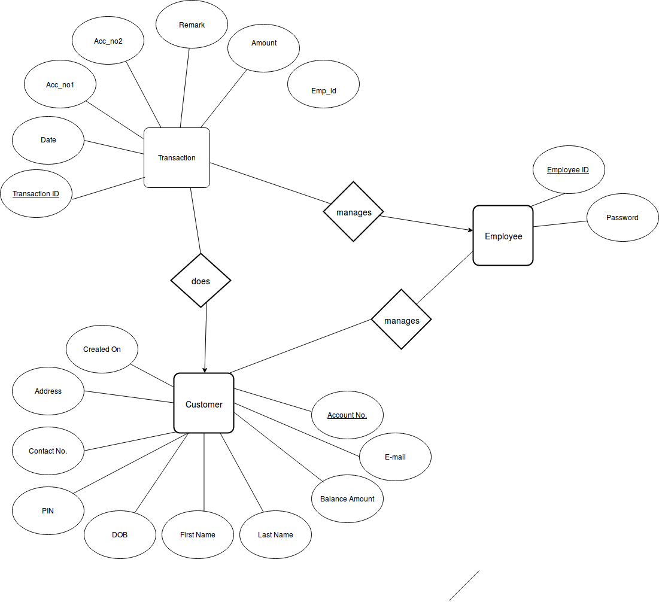

UML:
